# **Hands-On Exercise 04: Creating Spring Boot Actuator**

## **Let’s get Started**

## **Starting with Spring Initializr**

For all Spring applications, you should start with the [Spring Initializr](https://start.spring.io/). The Initializr offers a fast way to pull in all the dependencies you need for an application and does a lot of the set up for you. This example needs the Spring Web and Spring Boot Actuator dependencies.

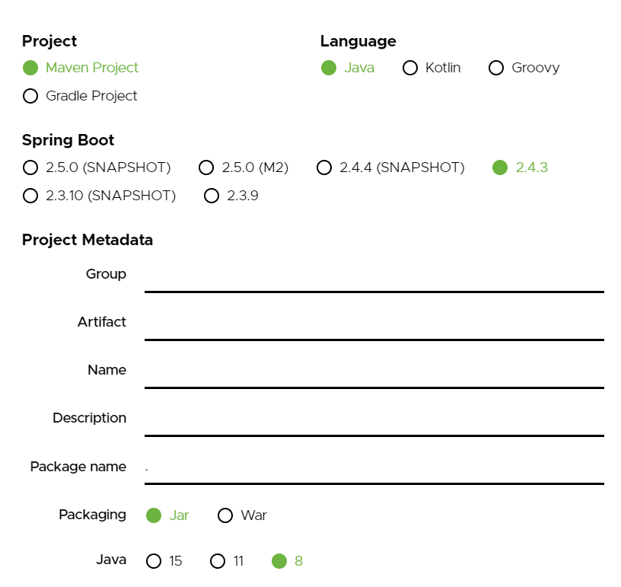

As shown in the image above, following steps have to be done

* Launch Spring Initializr and choose the following
  + Choose com.example as Group
  + Choose demo as Artifact
  + Choose following dependencies
    - Web
    - Actuator
    - DevTools
* Click Generate Project.
* Import the project into Eclipse/IntelliJ.
* If you want to understand all the files that are part of this project, you can go here.

Once all the dependencies are resolved get started by creating a controller for this exercise named as ***SimpleRestController.java,***

|  |
| --- |
| package com.example.demo;  import org.springframework.web.bind.annotation.GetMapping;  import org.springframework.web.bind.annotation.RestController;  import java.util.Date;  @RestController  public class SimpleRestController {  @GetMapping("/example")  public String example() {  return "Hello User !! " + new Date();  }  public static void main(String[] args) {  String text = "Sample Text for this Training.";  String substring = text.substring(3);  System.*out*.println(substring);  System.*out*.println(substring.length());      substring = text.substring(3, 10);  System.*out*.println(substring);  System.*out*.println(substring.length());  }  } |

Now let’s create application named as ***SpringBootActuatorExampleApplication.java,***

|  |
| --- |
| package com.example.demo;  import org.springframework.boot.SpringApplication;  import org.springframework.boot.autoconfigure.SpringBootApplication;  @SpringBootApplication  public class SpringBootActuatorExampleApplication {  public static void main(String[] args) {  SpringApplication.*run*(SpringBootActuatorExampleApplication.class, args);  }  } |

Now let’s run our code by clicking on the Runbutton, present on the top of the page.

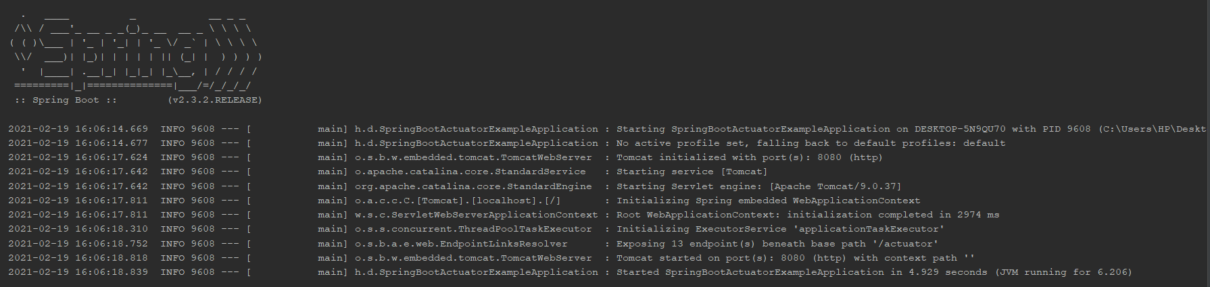

Now type localhost:8080/example for hitting the results required for actuator.

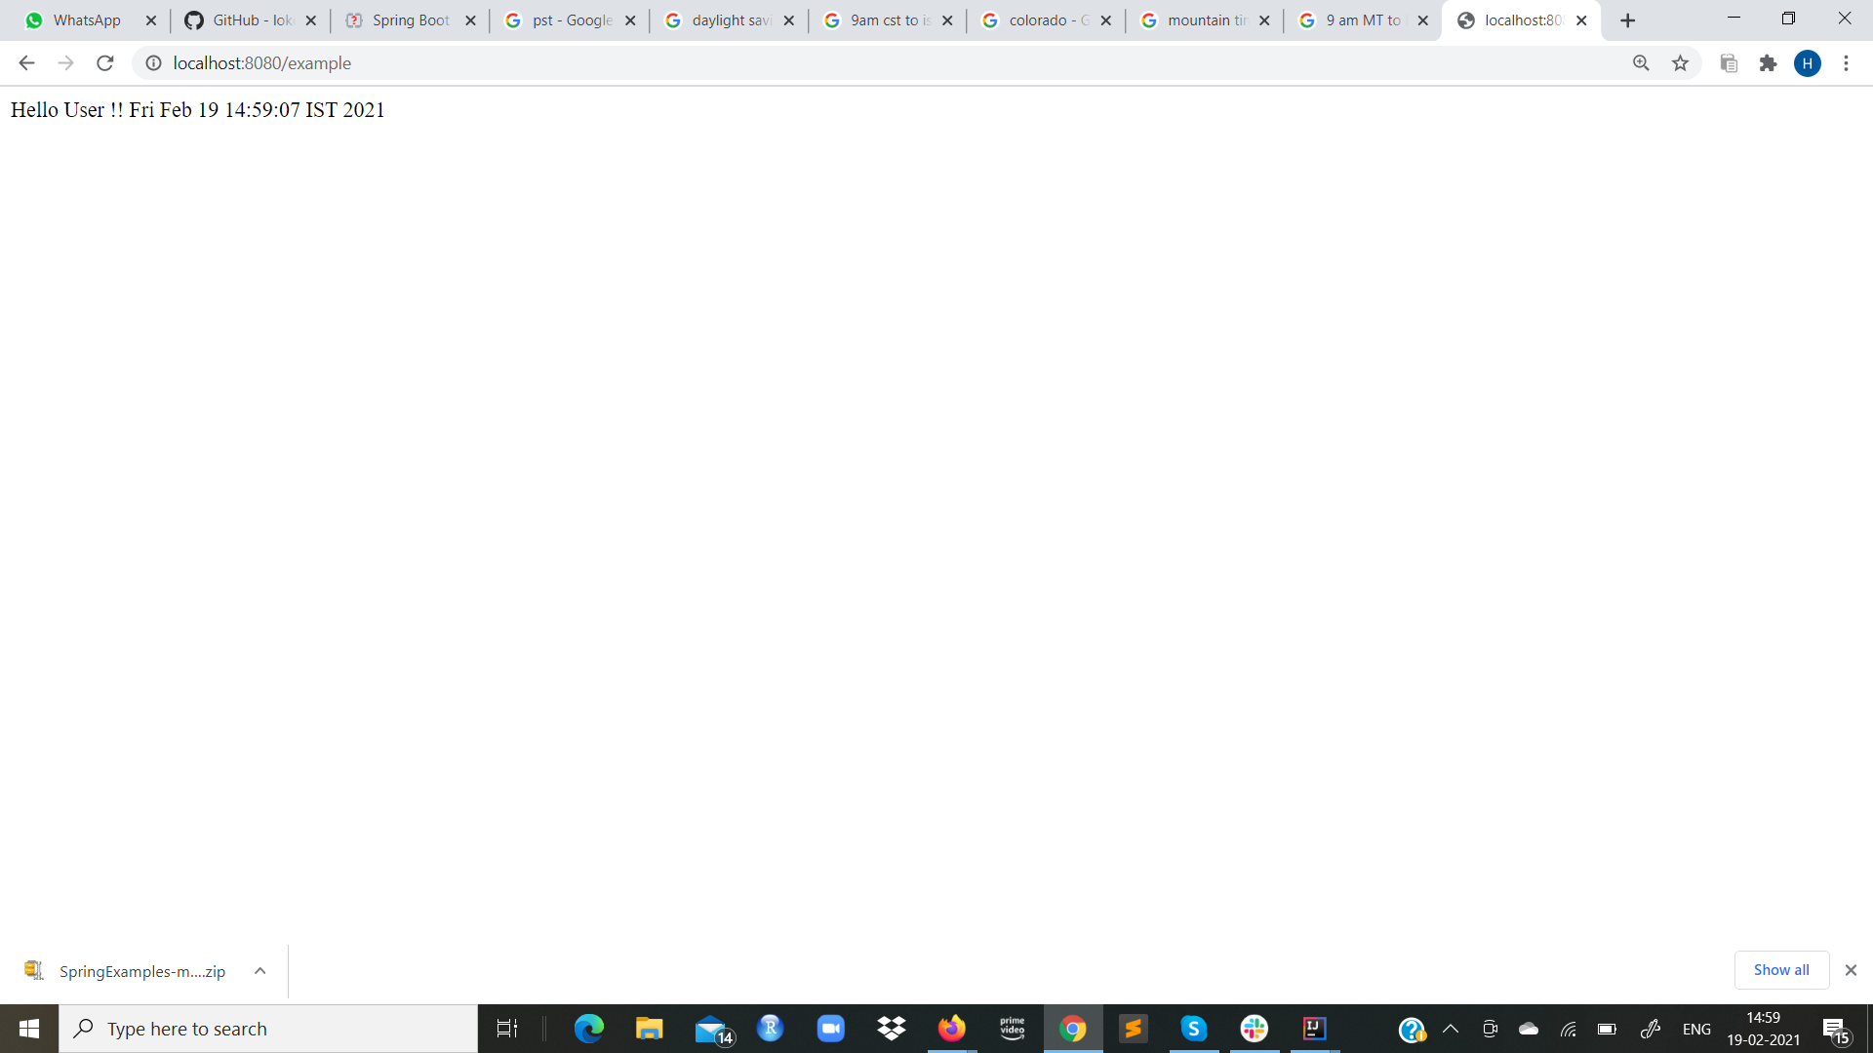

Finally type localhost:8080/actuator for watching the configurations of actuator.

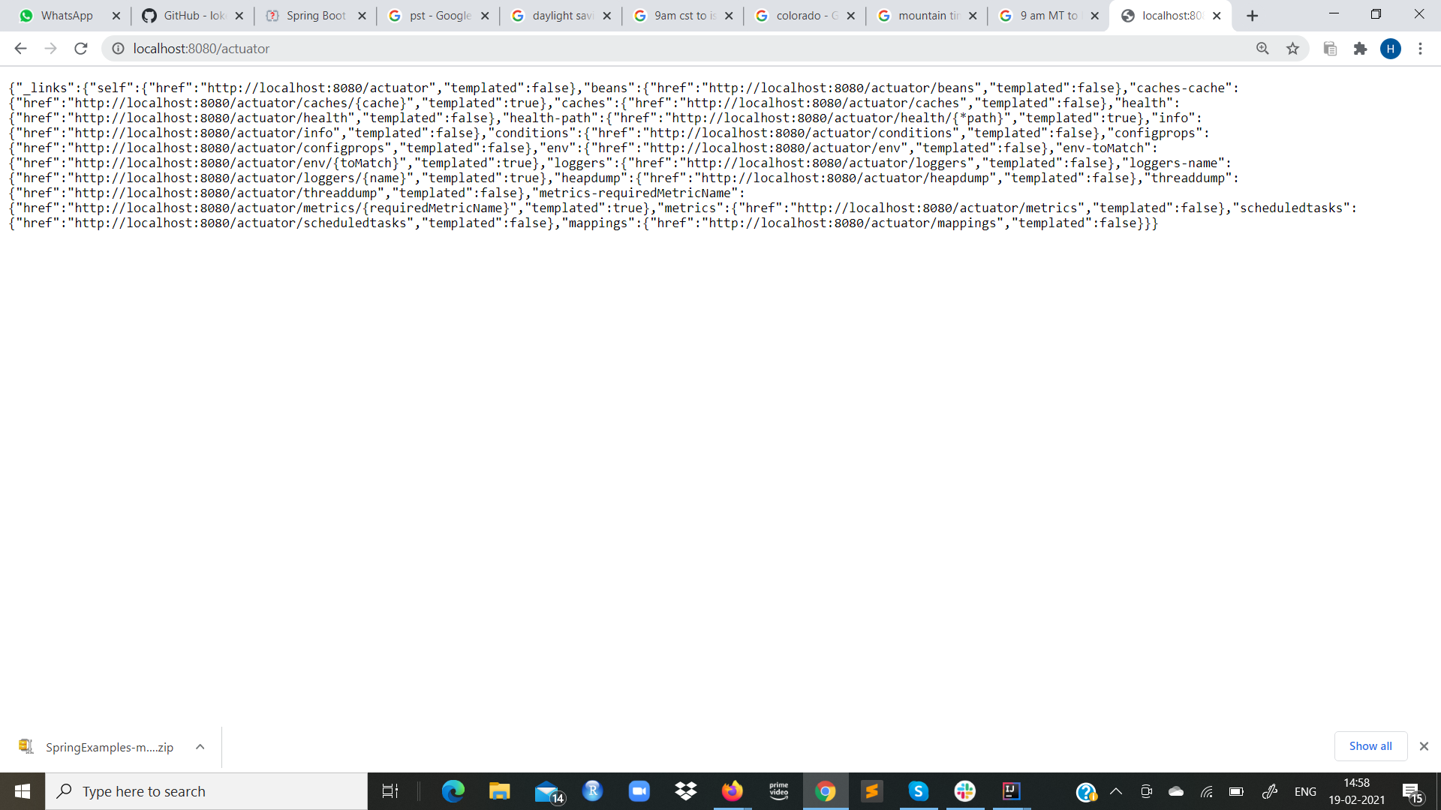

**Voila!!** We have successfully completed this Exercise.